## Overview

In this activity, you will customize the default Bootstrap 4 cards component to better reflect your site’s content.

## Instructions

**Part 1: Update the HTML**

1. Find the container-fluid <div> and add the class content.
2. Within the container-fluid <div>, but before the row <div>, add a <h2> tag.
   * Add the class sectionHeading.
   * Add the text **Shows Near You**.
3. Next, add the showsNear class to the row <div>.
4. Update the column sizing for each cardContainer <div> to col-lg-4 col-md-4 col-sm-12.
   * What do you think the size will be for each card on a small screen? What about a large screen?
5. Update each <img> tag to use pictures in the images folder.
6. Update the copy for each card and button to match the design, or get creative and add your own.

**Part 2: Update the CSS**

1. Add the following selectors and properties to style the cards section:

| **Selector** | **Properties and Values** |
| --- | --- |
| .content | padding: 50px; |
| .sectionHeading | text-align: center; |
| .showsNear | padding: 0px 30px 30px 30px; |
| .cardContainer | text-align: center; |

1. Now that you have finished the steps for this activity, your cards should be fully responsive with custom imagery.

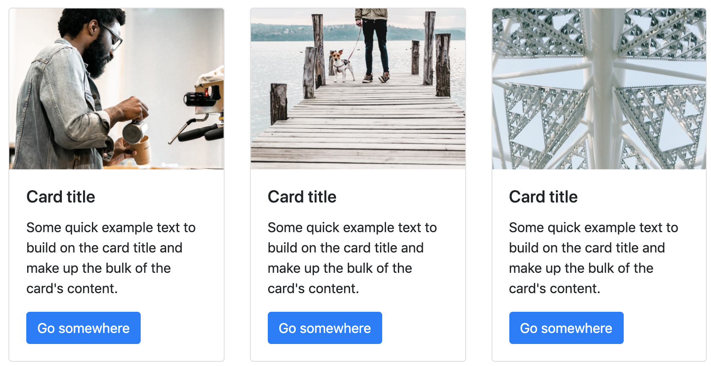

**⇩**

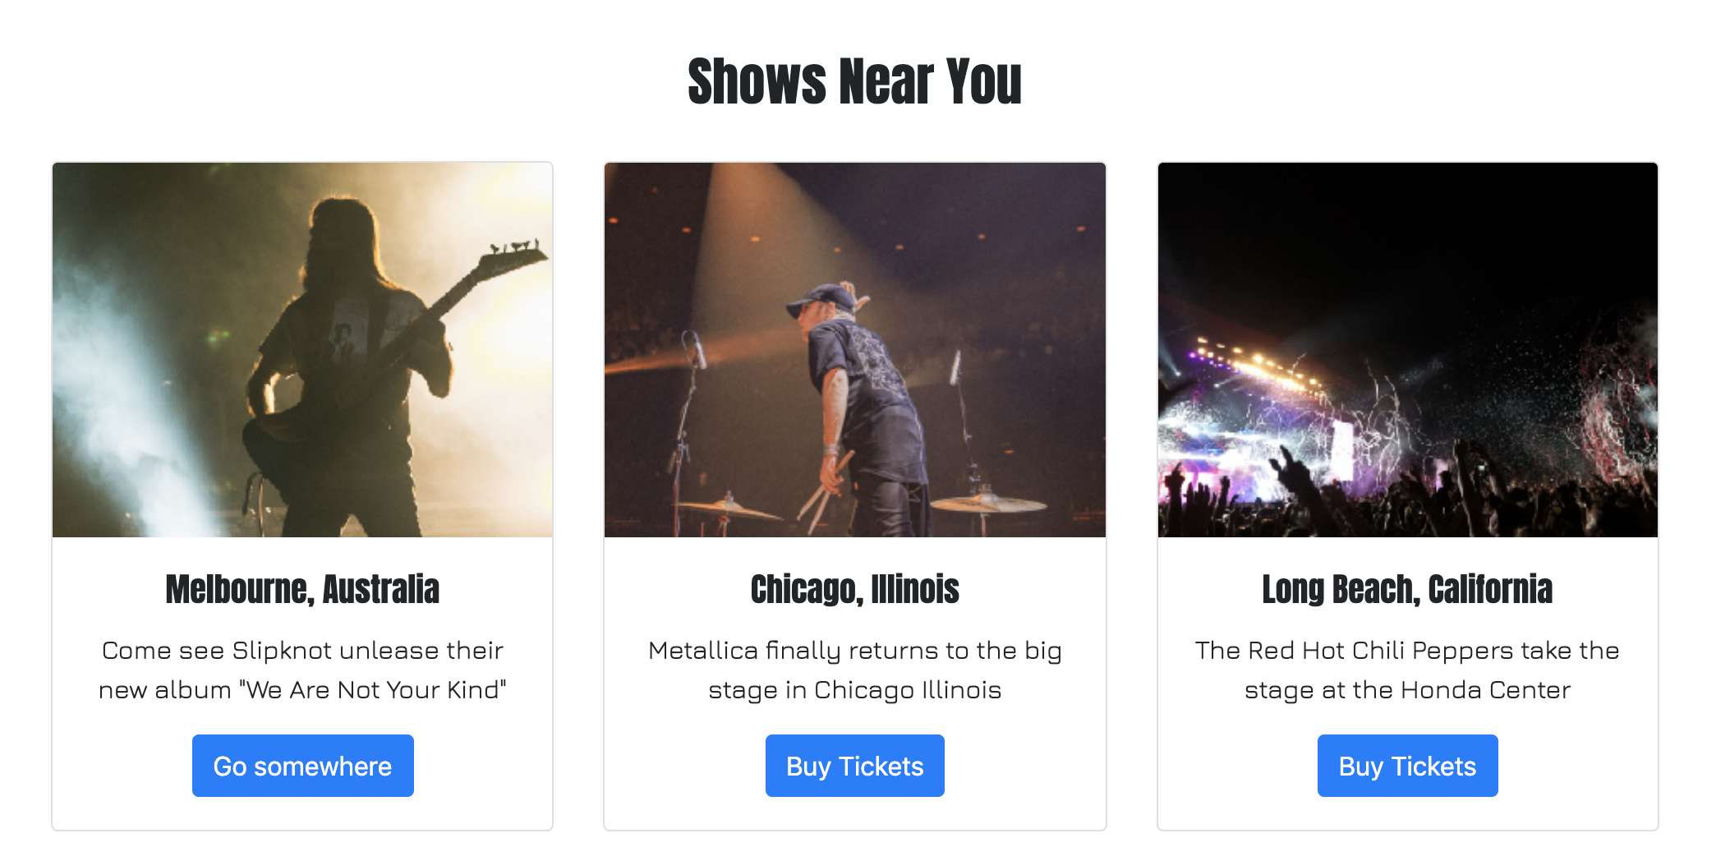

Great work!